Smart Password Validation
Time Limit: 1 second

People often make minor errors when entering passwords for one of their many accounts. This is becoming more of a problem with the rather lengthy passwords that many online portals require (the more characters in the password, the more chance there is to make a typing mistake). Touch typists are prone to another issue if one (or both) of their hands are not in the proper home row position when typing. This can cause all characters typed by a misplaced hand to be “one off”. Eg on a QWERTY keyboard, “lion” might become “kuib” if the right hand is placed one key to the left of normal home position.

The Frobozz Magic Security Company has decided to implement a new password validation algorithm that takes into account some common mistakes (but not all) made by folks when entering passwords on a QWERTY style keyboard (see picture below).

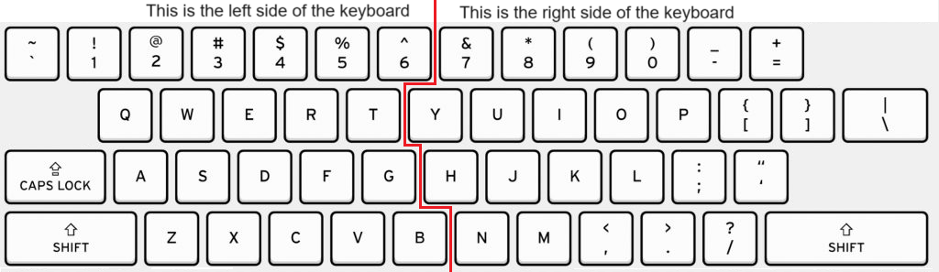

The algorithm looks for deviations from a correct sequence of keystrokes. For example, if the correct password is “ALg*”, the correct sequence, using the keyboard above, is "SHIFT-A, SHIFT-L, G, SHIFT-8". If the user were to accidentally hit the CAPS LOCK key before entering the password, but then used the correct sequence, they would end up typing "alG*" (note that the CAPS LOCK key affects only letters, not numbers or special symbols). Likewise, if the user accidentally placed the fingers of the left hand one space to the right of the correct position, made no other errors, and attempted to follow the correct sequence (unaware of the shift in finger positions: a good typist doesn't need to look at the keys!), they would type "SLh*". And if they also had the CAPS LOCK key pressed, they would type "slH*".

Finally, a user might accidentally insert or delete a character. Such an error is understandable if the password is very long; however, it is a serious enough error that no other errors should be permitted other than a CAPS LOCK error. The remaining characters should all follow the correct sequence of key presses.
The Frobozz Magic Security Company has decided to permit certain deviations, or combinations of deviations, from the correct sequence:

Name | Acronym | Description | Examples
Left side “off by one” | LS | All characters on the left side of the keyboard are shifted right by one key. The left-shift key shifted right by one key is still the left-shift key. | FlatHead ⇨ GlsyHrsf
Right side off by one | RS | All characters on the right side of the keyboard are shifted left by one key. The right-shift key shifted left by one key is still the right-shift key. | FlatHead ⇨ FkatGead
Single Extra character | EC | The password exceeds a certain minimum length and there is one additional character. | Zorkmid⇨Zorkmiid  (extra i)
Single Missing character | MC | The password exceeds a certain minimum length and there is a single missing character. | FCD#3⇨FCD3  (missing the #)
CAPS LOCK was in effect by mistake | CL | All lowercase letters appear as uppercase and all uppercase letters appear as lowercase | WE do it! ⇨  we DO IT!

LS, RS, EC and MC are mutually exclusive. A password is accepted as valid if it matches exactly (no errors), or follows the rules described above.

Input
There are multiple lines of input. The first line contains a string, P, which is the correct password (2 ≤ Length(P) ≤ 24). The second line contains a single positive integer N, (0 < N ≤ 1000), which is the number of lines that follow. Each of the following N lines contains a single password to test, T_{n}, (Length(P)-1 ≤ Length(T_{n}) ≤ Length(P)+1). The characters for all passwords come ONLY from those that appear on the QUERTY keyboard picture above, as well as the lowercase letters.

Output
Output consists of N lines. For each T_{n} the line should consist of the word NO if T_{n} does not match the password P using Frobozz’s algorithm or if T_{n} does match the password P using Frobozz’s algorithm, YES followed by a space separated list of acronym(s) from table above, in the order they appear in the table, giving the reason(s) for the match. If the T_{n} exactly matches the password P, use the acronym EX.

Sample Input | Sample Output
Password=`A:'  9  Password=`A:'  pASSWORD=`a:'  Psddeotf=1S:'  oASSWIRD-`al;  Password=`A:'x  pASWORD=`a:'  pASSWORD=`a:'X  Osddeitf-1SL;  Psdeotf=1S:' | YES EX  YES CL  YES LS  YES RS CL  YES EC  YES MC CL  YES EC CL  NO  NO

